**Botpress offers direct integration into programs such as Facebook messenger, Microsoft Teams, Slack, and Telegram. This document is meant to compile documentation to integrate the chatbot to the Speedy Snacks Flutter application.**

**Embedding**

<https://botpress.com/docs/messaging-channels/botpress-webchat/website-embedding/>

**How to use JS with Flutter application in Dart (embedding the botpress JS script)**

<https://fireship.io/snippets/using-js-with-flutter-web/>

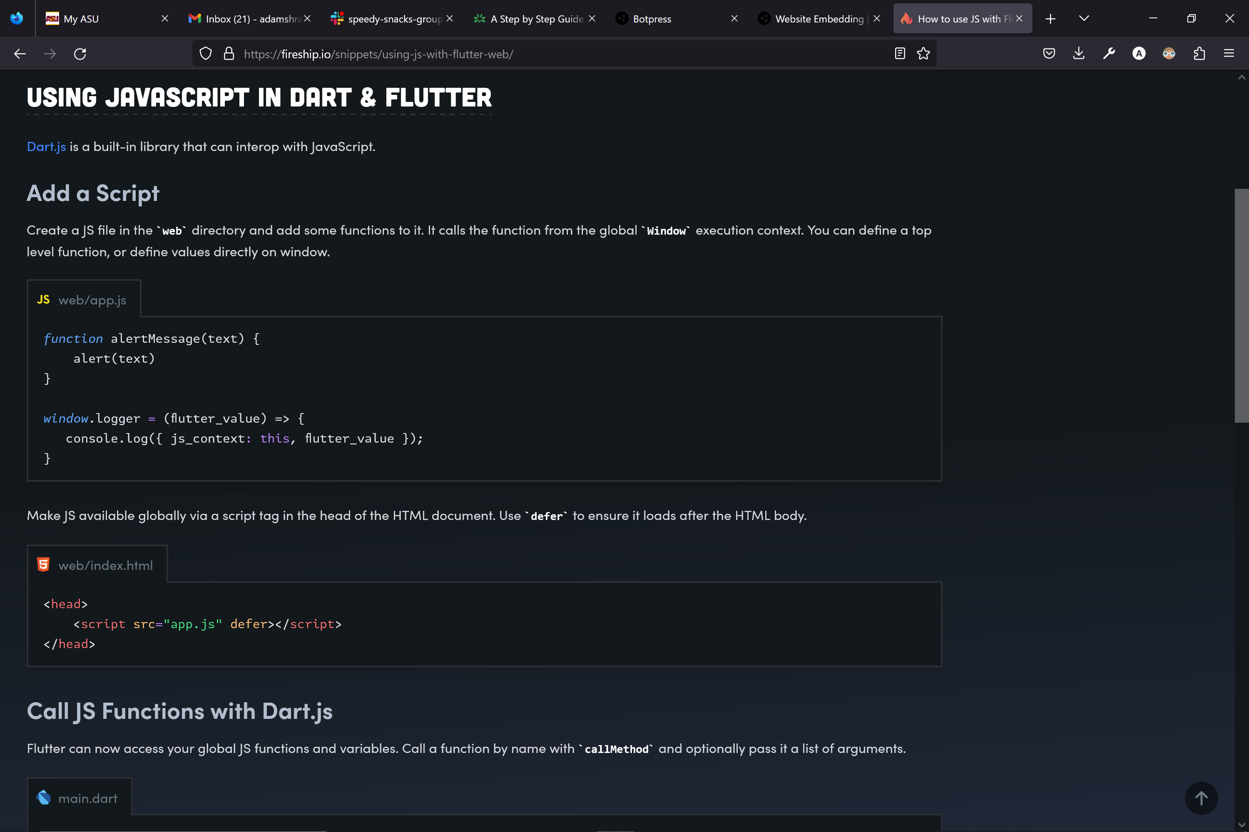

**In depth tutorial adding a JS object script to a Flutter application**

<https://liewjuntung.medium.com/use-javascript-in-flutter-web-a6eed3efb9a0>

